***Gourmet Pitt Tour***

***Design Document***

*18 Jul 2015*

1. **Designing Screen**

According to statistics on Android developer website, for screen size, most devices use size “Normal” and size “Large”, and the percentages are 83.3% and 8.6%. Meanwhile, for density, hdpi and xhdpi are most popular, which account for 40.8% and 21.0% of the devices. Thus, we would design our wireframes such that they can be used on screens of size “Normal” and size “Large”. And most images we use would be in hdpi(high) and  xhdpi(extra-high) drawables. Additionally, <supports-screens> element should be included in manifest file to declare the screen sizes the application supports.

1. **Designing Presentation Tier**

In our design, intents used for page flow are defined in the following table and is displayed in the Fig. 1 Intent Diagram.

Intent ID starting with A is implemented by both Customer and Business;

Intent ID starting with C is implemented only by Customer;

Intent ID starting with B is implemented only by Business.

|  |  |  |  |
| --- | --- | --- | --- |
| Intent ID | Intent Name | Source Activity | Des Activity |
| A1 | Register | Login | CreateAccount |
| A2 | SuccessRegister | CreateAccount | Login |
| A3 | Cancel | CreateAccount | Login |
| C4 | CustomerLogIn | Login | CustomerHome |
| B4 | BusinessLogIn | Login | BusinessHome |
| C5 | Search | FindNearBy (Fragment) | SearchResult |
| C6 | Search | Recommendation (Fragment) | SearchResult |
| C7 | Search | Search (Fragment) | SearchResult |
| C8 | ChooseRestaurant | SearchResult | CusRestDetail |
| C9 | CustomerReservation | CusRestDetail | MakeReservation |
| B5 | MyRestaurant | BusinessHome | BusinessMyRestaurant |
| B6 | PersonalInfo | BusinessHome | BusinessPersonal |
| B7 | SelectRestaurant | BusinessMyRestaurant | BusinessRestDetail |
| B8 | DeleteRestaurant | BusinessMyRestaurant | BusinessRestDelete |
| B9 | EditRestaurant | BusinessMyRestaurant | BusinessRestEdit |
| B10 | BusinessReservation | BusinessRestDetail | BusinessReservationList |
| B11 | AddDishes | BusinessRestEdit | BusinessDishesAdd |
| B12 | DeleteDishes | BusinessRestEdit | BusinessDishesDelete |

Table 1. Intent Table

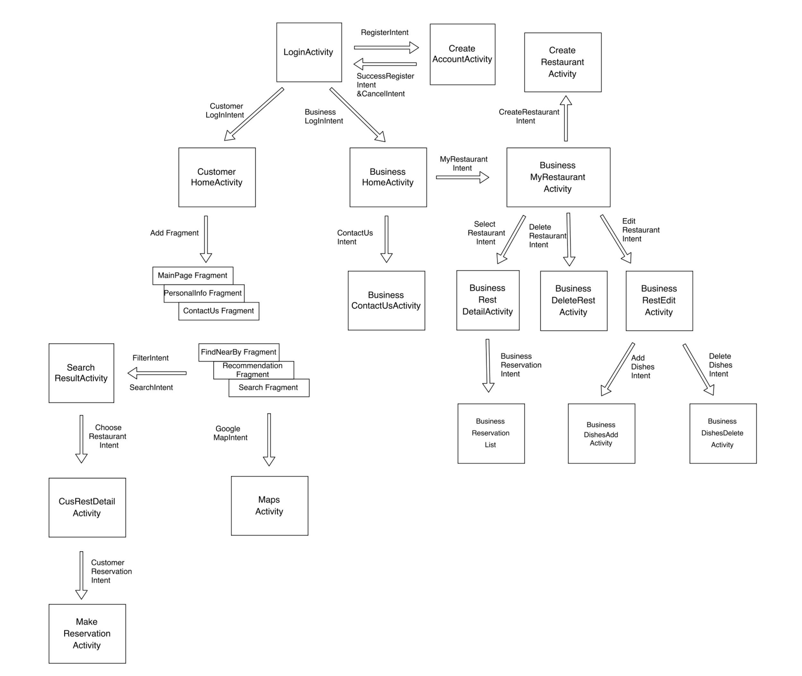

**Fig. 1 Intent Diagram**

1. **Designing Content Provider**
   1. **Database design**

Three databases are used in our project. The Customer Database and Business Database are deployed locally, storing related customer or business data. Server Database is deployed in the remote server side, storing all the information occurred in the App.

* 1. **Database Schema**

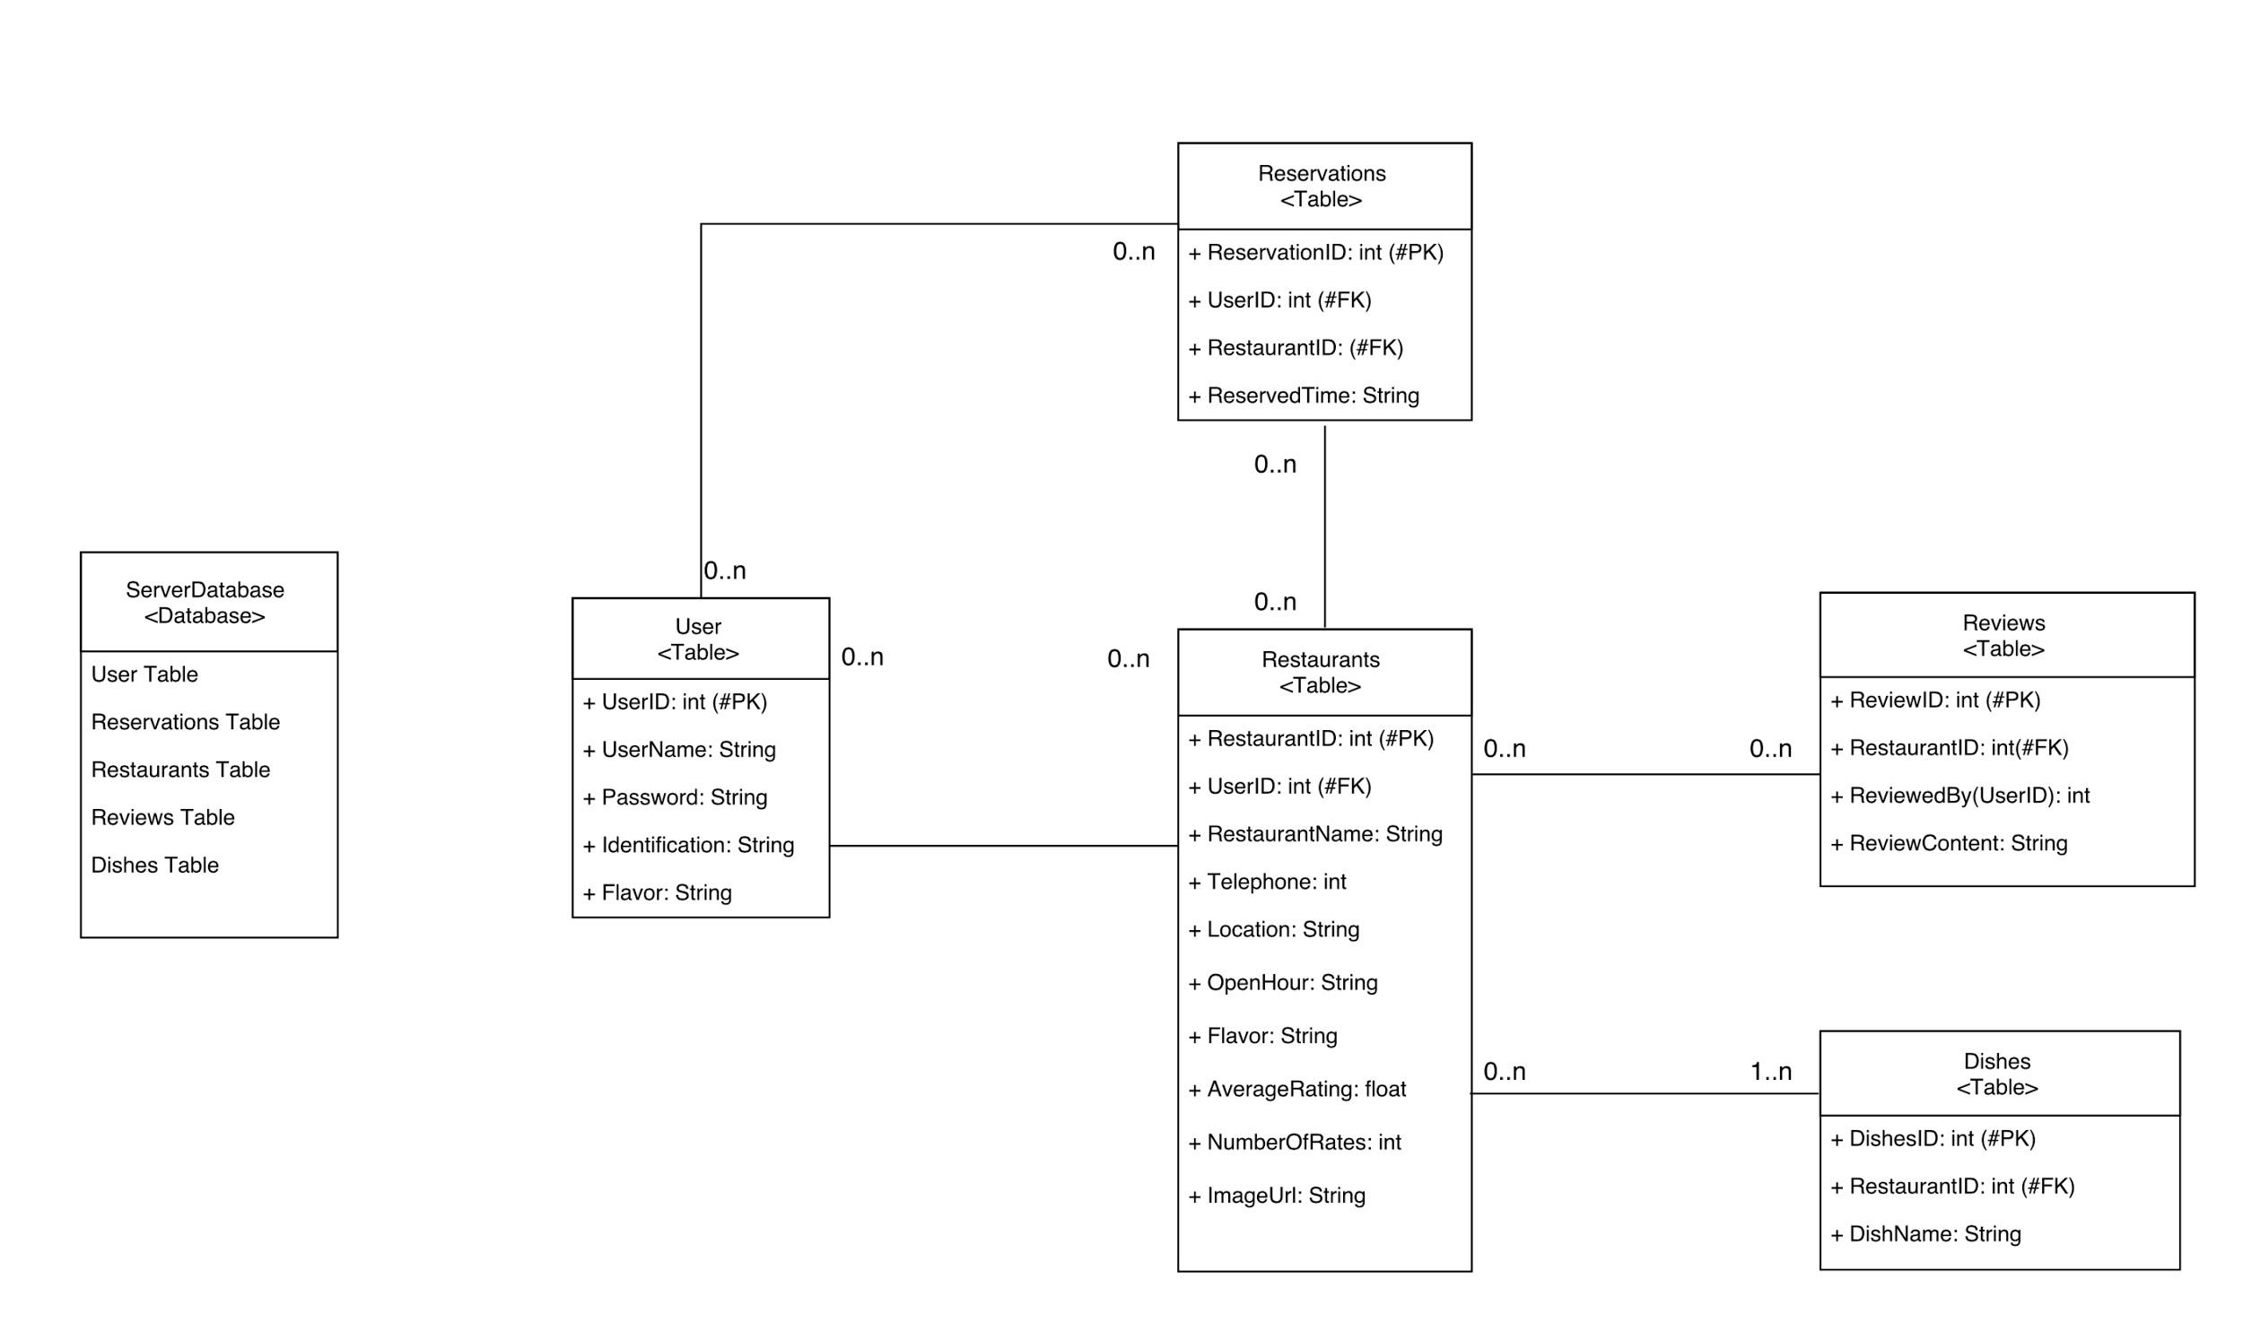

**Fig. 2 Server Database**

1. **Designing Application Tier**

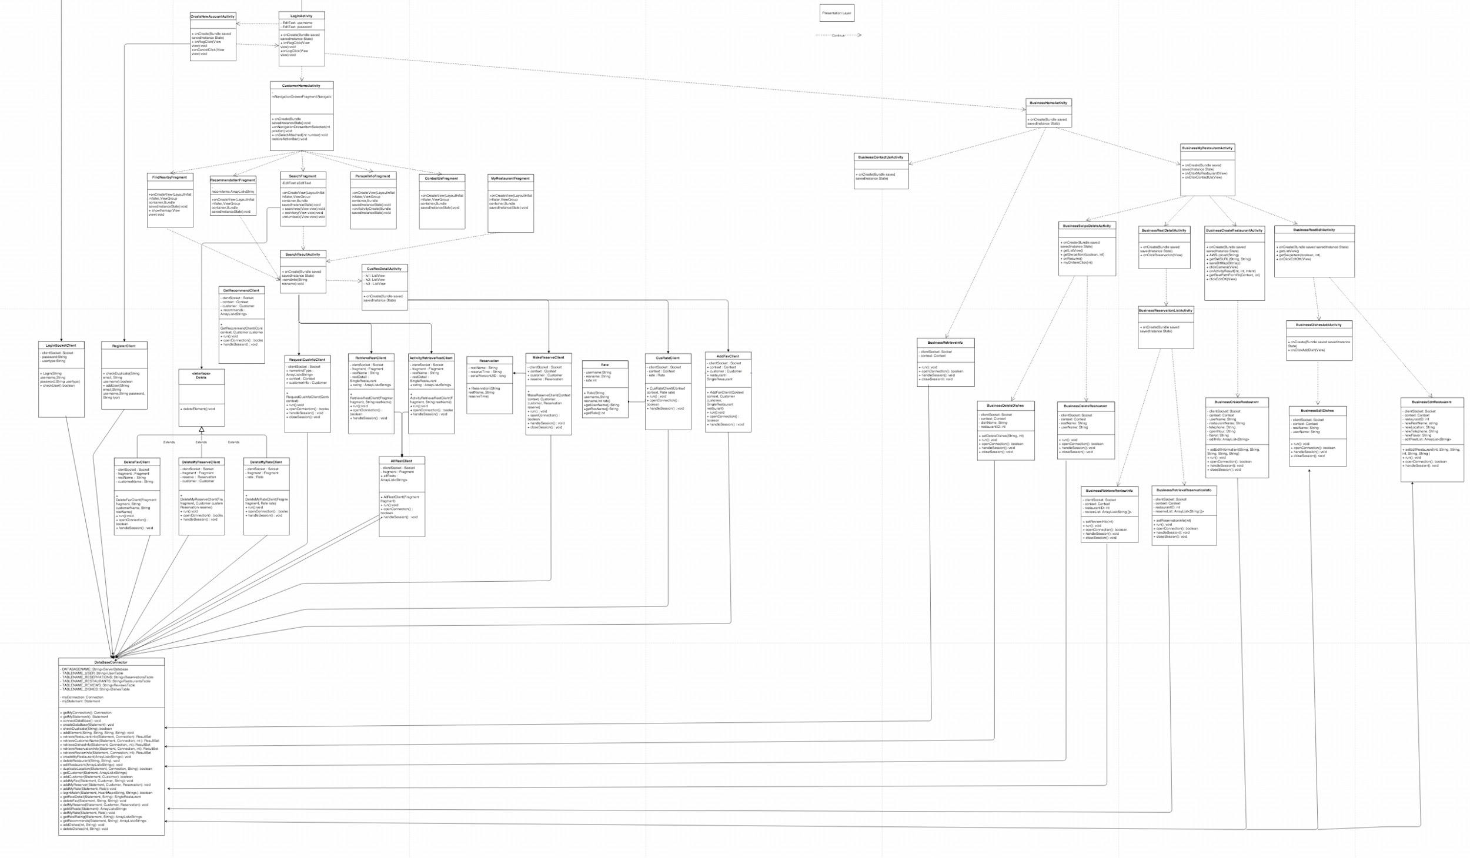

**Fig. 3 UML**

1. **Designing Integration Tier**

The Customer Database and Business Database are deployed locally, storing related customer or business data. Server Database is deployed in the remote server side, storing all the information occurred in the App. Both Local and remote database are connecting with the logic layer for data transfer.

Some data such as username, my favorite, my review and my reservation are stored at Customer Database whenever they are successfully created in the logic layer when the user is a customer. Information in local database is mainly used in the PersonalInfo activity for display.

Similar to the Customer Database, Business Database is the one used by a restaurant owner to temporarily store data related with restaurants, such as basic restaurant information.

Server Database is served as the remote database to store information about all users and restaurants, including reservations and ratings. The user interface display to users after successful login is constructed using data retrieved from the remote database.